**Event Report of Club/Committee Debate Club DC001**

|  |  |
| --- | --- |
| **Name of the Club** | Debate Club |
| **Name of the Event** | Debate Session on One Nation One Election |
| **Student Vertical** | Engineering |
| **Instalment** | 1 |
| **Date and Time of the Event** | 21st February 2026, 4:00 PM |
| **Mode of the Event** | Offline |
| **Venue** | VIT Biwewadi, Room No. 1002 |
| **No. of Participants** | 80 (Students and Faculty) |
| **Duration of Event** | 2 hours |
| **Name of Guests** | Dr. Rajesh Kumar |
| **Designation of Guests** | Professor and Head of Department |
| **Nature of Guest** | Internal |
| **Event Category** | Academic and Co-curricular |
| **Event organized in collaboration with** | Student Council |
| **Resource person details if any** | Dr. Rajesh Kumar, Professor and Head of Department |
| **Achievements & Highlights** | Successful organization of the debate session with active participation from students |

|  |  |  |  |
| --- | --- | --- | --- |
| **S.No.** | **Program Outcome** | **Rating (0-3)** | **Remarks** |
| 1 | Engineering knowledge: Apply the knowledge of mathematics, science, engineering fundamentals, and an engineering specialization to the solution of complex engineering problems | 2 | Good application of engineering knowledge |
| 2 | Problem analysis: Identify, formulate, review research literature, and analyze complex engineering problems reaching substantiated conclusions using first principles of mathematics, natural sciences, and engineering sciences | 3 | Excellent problem analysis skills |
| 3 | Design/development of solutions: Design solutions for complex engineering problems and design system components or processes that meet the specified needs with appropriate consideration for the public health and safety, and the cultural, societal, and environmental considerations | 2 | Good design and development skills |
| 4 | Investigation of complex problems: Investigate, analyze, and solve complex problems and identify the key elements and relationships | 3 | Excellent investigation skills |
| 5 | Modern tool usage: Create, select, and apply appropriate techniques, resources, and modern engineering and IT tools including prediction and modeling to complex engineering activities with an understanding of the limitations | 2 | Good usage of modern tools |
| 6 | The engineer and society: Apply reasoning informed by the contextual knowledge to assess societal, health, safety, legal, and cultural issues and the consequent responsibilities relevant to the professional engineering practice | 3 | Excellent understanding of societal context |
| 7 | Environment and sustainability: Understand the impact of the professional engineering solutions in societal and environmental contexts, and demonstrate the knowledge of, and need for sustainable development | 2 | Good understanding of environmental impact |
| 8 | Ethics: Apply ethical principles and commit to professional ethics and responsibilities and norms of the engineering practice | 3 | Excellent understanding of ethics |
| 9 | Individual and team work: Function effectively as an individual, and as a member or leader in diverse teams, and in multidisciplinary settings | 2 | Good teamwork and communication |
| 10 | Communication: Communicate effectively on complex engineering activities with the engineering community and with society at large, such as, being able to comprehend and write effective reports and design documentation, make effective presentations, and give and receive clear instructions | 3 | Excellent communication skills |
| 11 | Project management and finance: Demonstrate knowledge and understanding of the engineering and management principles and apply these to one’s own work, as a member and leader in a team, to manage projects and in multidisciplinary environments | 2 | Good project management skills |

## GEO-Tagged Photograph Section

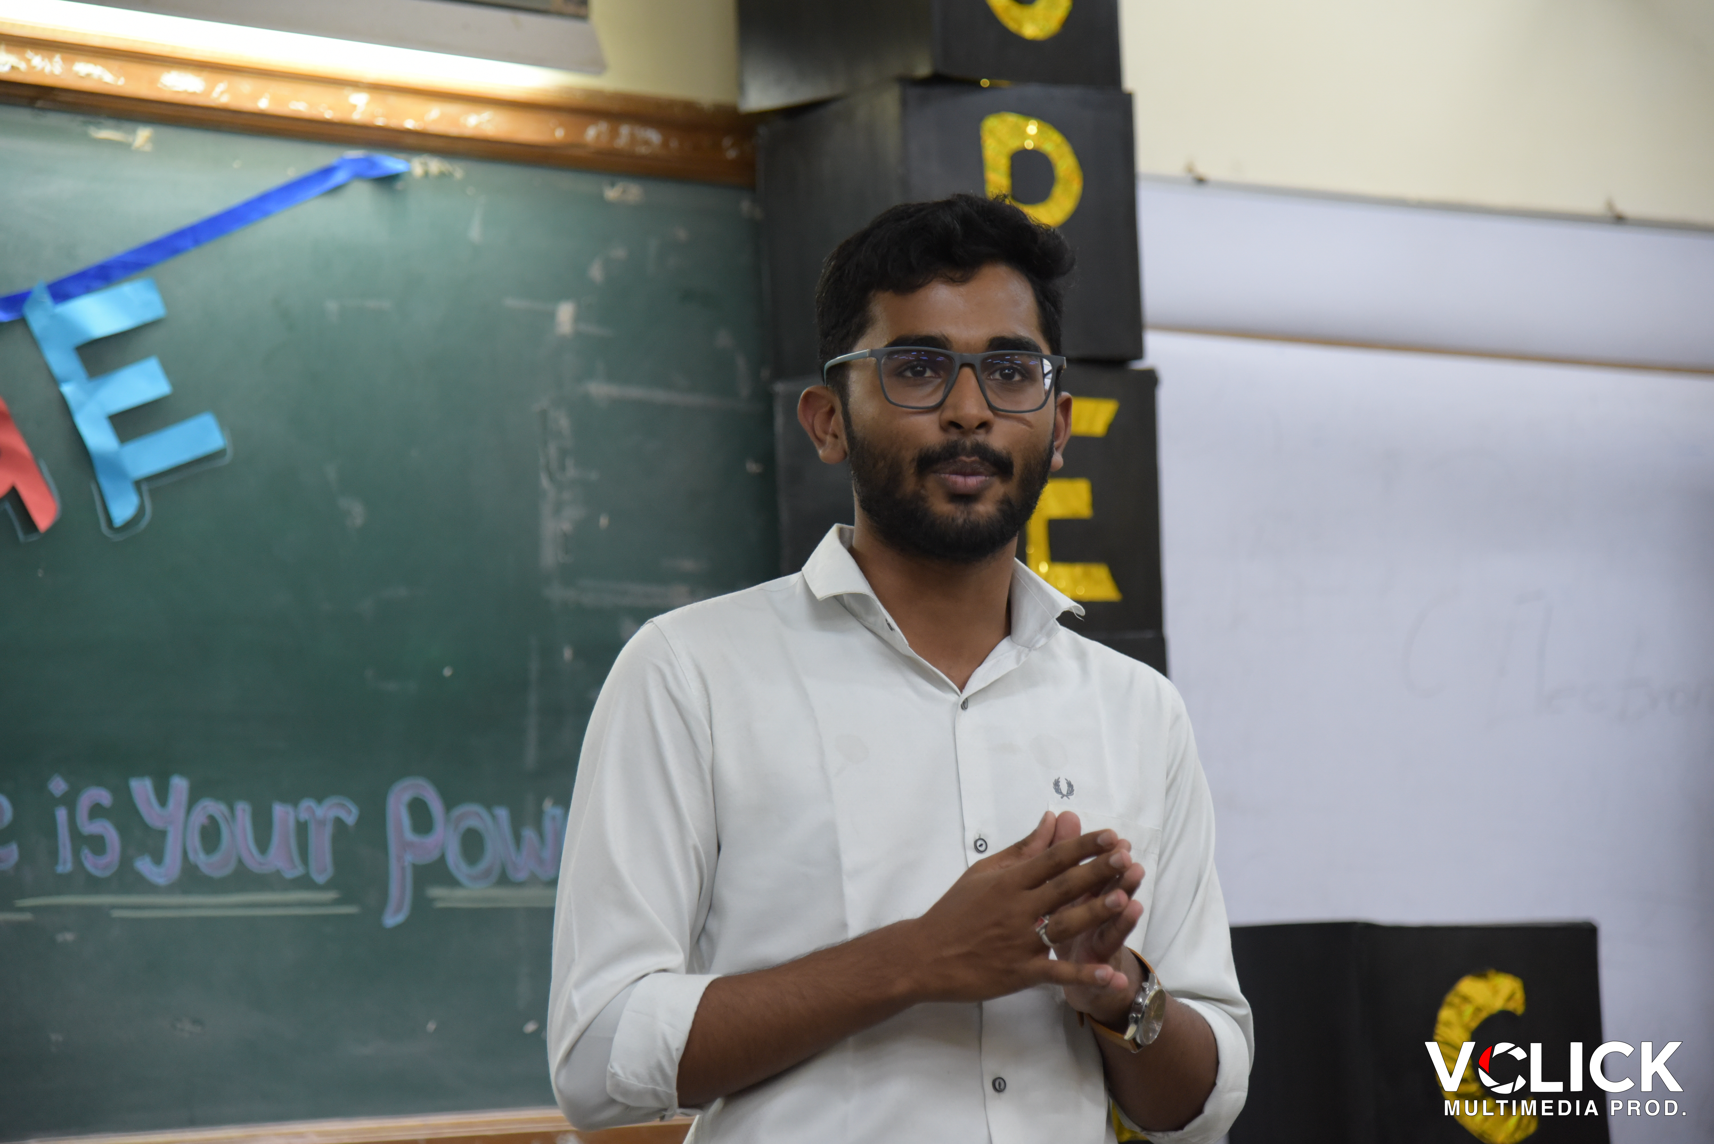

Image: Speakers_edge_-80.jpg

* Photo 1: Group photo of participants and guests in front of VIT Biwewadi, Room No. 1002
* Photo 2: Dr. Rajesh Kumar, Professor and Head of Department, addressing the participants
* Photo 3: Students actively participating in the debate session

## Non GEO-Tagged Photograph Section

* Photo 1: Debate session in progress
* Photo 2: Participants engaging in a discussion
* Photo 3: Dr. Rajesh Kumar presenting a certificate to a participant

|  |  |
| --- | --- |
| **Additional Details** | Description |
| **Event Coordinator** | Mr. John Doe |
| **Event Volunteers** | 5 students from Debate Club |
| **Event Expenses** | 10000 INR |
| **Event Sponsorship** | 5000 INR from Student Council |

|  |  |
| --- | --- |
| **Guest Name** | Designation |
| **Dr. Rajesh Kumar** | Professor and Head of Department |
| **Mr. Jane Doe** | Industry Expert |

|  |  |
| --- | --- |
| **Participant Name** | Student ID |
| **John Doe** | SE101 |
| **Jane Doe** | SE102 |
| **...** | ... |

________________________________________________________________________________

Generated by CampusOps Event Report Generator  
Date: February 26, 2026 at 11:53 PM